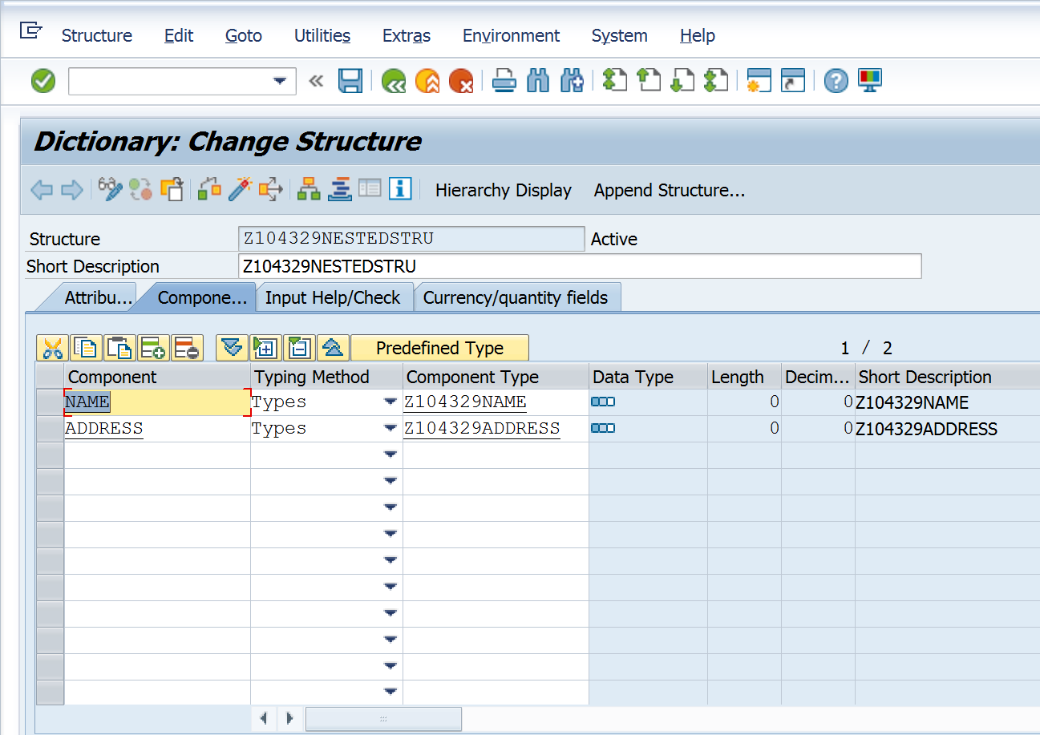

REPORT z.

DATA WA_NAME TYPE Z104329NAME. “not needed.

DATA WA_NESTEDSTRU TYPE Z104329NESTEDSTRU.

WA_NESTEDSTRU-NAME-FIRSTNAME = 'Vandana'.

WA_NESTEDSTRU-NAME-LASTNAME = 'Koleshwar'.

WA_NESTEDSTRU-ADDRESS-STREET = 'Neurott Str 15 a'.

WA_NESTEDSTRU-ADDRESS-ZIPCODE = 'D-69190'.

WA_NESTEDSTRU-ADDRESS-CITY = 'Walldrof'.